 | 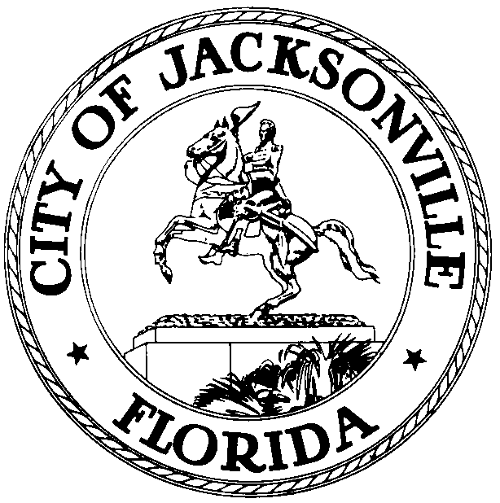
 | OFFICE OF THE CITY COUNCIL
Scott Wilson  Council Member, District 4 |  | 117 W Duval Street  City Hall, Suite 425
Office (904) 630-1394 |  | Jacksonville, FL 32202
Fax (904) 630-2906
E-Mail: swilson@coj.net

October 12, 2016
3:00 PM

TO: Neighborhoods, Community Investments & Services Committee Members
Honorable Council Member Reggie Brown, Vice Chair
Honorable Council Member Doyle Carter
Honorable Council Member Garrett Dennis
Honorable Council Member Bill Gulliford
Honorable Council Member Joyce Morgan

FROM: Scott Wilson, Chair

SUBJECT: 2016-2017 Neighborhoods, Community Investments & Services Agenda Meeting Change of Location

Notice is hereby given that the NCIS Chair, Scott Wilson, will meet with the NCIS Committee Members in the Council Chambers located at 117 W. Duval St., 1st Floor, St. James Building, at 8:30 AM prior to each regularly scheduled NCIS Committee meeting. This location change is effective October 17, 2016 and for the remainder of the Council year. Please revise your calendars accordingly. As always, all interested parties are invited to attend. If you have any questions, please contact Juliette Williams, Legislative Assistant at 630-1404.

SW/jw

cc: Council Members/Staff
Cheryl Brown, Director/Council Secretary
Carol Owens, Chief, Legislative Services Division
Jeff Clements, Chief, Research
Kristi Sikes, Chief, Administrative Services Division
Council Auditor’s Office
Office of the General Counsel
CityC@coj.net
Posted Meeting - City Council Calendar
Electronic Notification - 1st Floor City Hall
Public Notice System - City Council Webpage
Media Box
File Copy

